**Custom Reports – Practice Exercise**

Use the Fitness database from Blackboard

Create this report, using an image of your choice

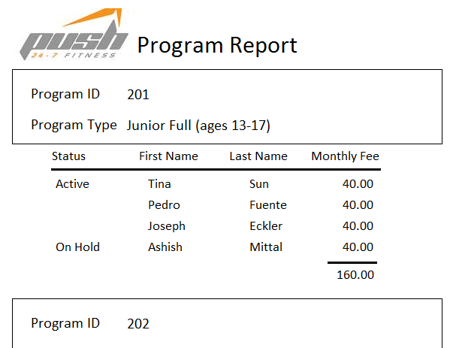

Duplicate values hidden

Duplicate values hidden

Total

* Create a query using all fields required
* Create a report using Wizard and use the query, this started out in Outline view
* Move Monthly Fee to Detail Area, you’ll have to cut and paste control
* Add a total
* Hide Duplicate Values
* Remove borders from controls and add line control
* Add a conditional formatting rule of your choice